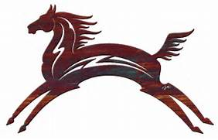
"Horse Spirit Medicine"
Shamanism & Yoga Retreat
with Joyce St. Germaine, M.S. Ed, CHt, RYT-200

Saturday, July 8, 2017 Noon - 8 PM
at the home and barn of Dana Stuart-Bullock, 101 Hat Shop Road, Bridgewater, CT 06752
Explore the perfect fusion of Yoga and Shamanism!
Horses offer the spirit medicine of "Personal Power". Discover yours and reclaim it! Although there are two mustang horses and a donkey on the premises, we may or may not be invited by them to interact. The spirit medicine of horse will be deeply felt by their very presence. We will engage in guided shamanic journeying to greet and spend time with these powerful spirit helpers.

You will experience:

- Heart Chakra Connection of Earth and Sky
- Cross-Cultural Shamanic Activities
- Shamanic Journeying
- Meditation
- Chakra Clearing and Balancing
- Journaling Exercises
- Hiking/Walking
- Creating a Personal Power Talisman
- Fire Ceremony
- Gentle Yoga Poses and/or Chair Yoga
- Yoga Mudras or Hand Postures
- Closing Drum Circle and Fireside Chat

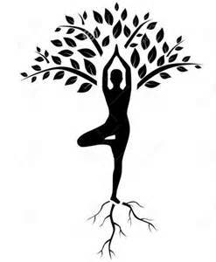
All levels of yogic and shamanic experience are welcome!
Yoga modifications will include gentle chair poses.
$125 for adults or $110 for teens, elders over 65, and veterans.
(cash or check only)
INCLUDED: Fruits, nuts, cheese, hummus, raw veggies, crackers (including GF),
coffee, tea, and water.
Please bring whatever else you might want to suit your dietary needs.
Pre-registration is required as spaces are limited!
To reserve, call Joyce: (860) 675-9706 or email: jsgermaine@aol.com. Dana: (347) 225-4278
Materials list given upon registration.

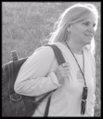
Joyce St. Germaine, M.S. Ed., CHt., RYT-200 is a Certified Shamanic Practitioner, Certified Shapeshifting Practitioner, Certified Hypnotherapist, Spiritual Counselor, Registered Yoga Teacher and Artist. She is Owner/Director of The Sacred Journey Center for Spiritual Studies in Burlington, CT.
Joyce can be reached at www.thesacredjourney.biz, jsgermaine@aol.com, (860) 675-9706

